THE RACIST EMAILS

What you are about to see is an email that suggests the predominantly African Americans who wear t-shirts supporting President Barack Obama are more likely to get arrested then those who wear shirts of former White Presidents.

During that time Robert Stryk , a candidate for Yountville Mayor was complaining about police intimidation and also speaking out against the racism that is very prevalent in Yountville and the Napa Valley Sheriff’s Department.

Sharon Stensaas of the Yountville Sun wrote a piece about the incident and called it nothing more then political satire and portrayed Mr. Stryk as making a big deal out of nothing.

Mr. Stensaas refused to print Mr. Stryk’s response which we have pasted below.

What do you think of the email below? Do you think it is a big deal?

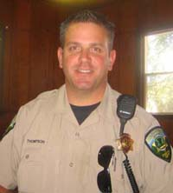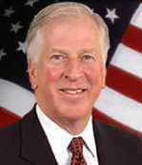
Napa County Deputy John Thompson U.S. Congressman Mike Thompson
Below is an email chain from Deputy John Thompson from his official Napa County Sheriff’s email as well as to SGT. Keith Behlmer, also on his official Napa County Sheriff’s email.

It is of note that Deputy Thompson also happens to be the son of Napa Valley Democratic United States Congressman Mike Thompson.
From: Thompson, Jon
Sent: Monday, July 20, 2009 10:18 AM
To: Pike, Douglas; McMahon, Patrick; Behlmer, Keith; Crawford, Jon; Claudino, Lisa; MacDonald, William
Subject: FW: Police photos.....hehehehehehhee
This was sent by a Deputy Sheriff.
The New Fashion Rage In Mug Shots
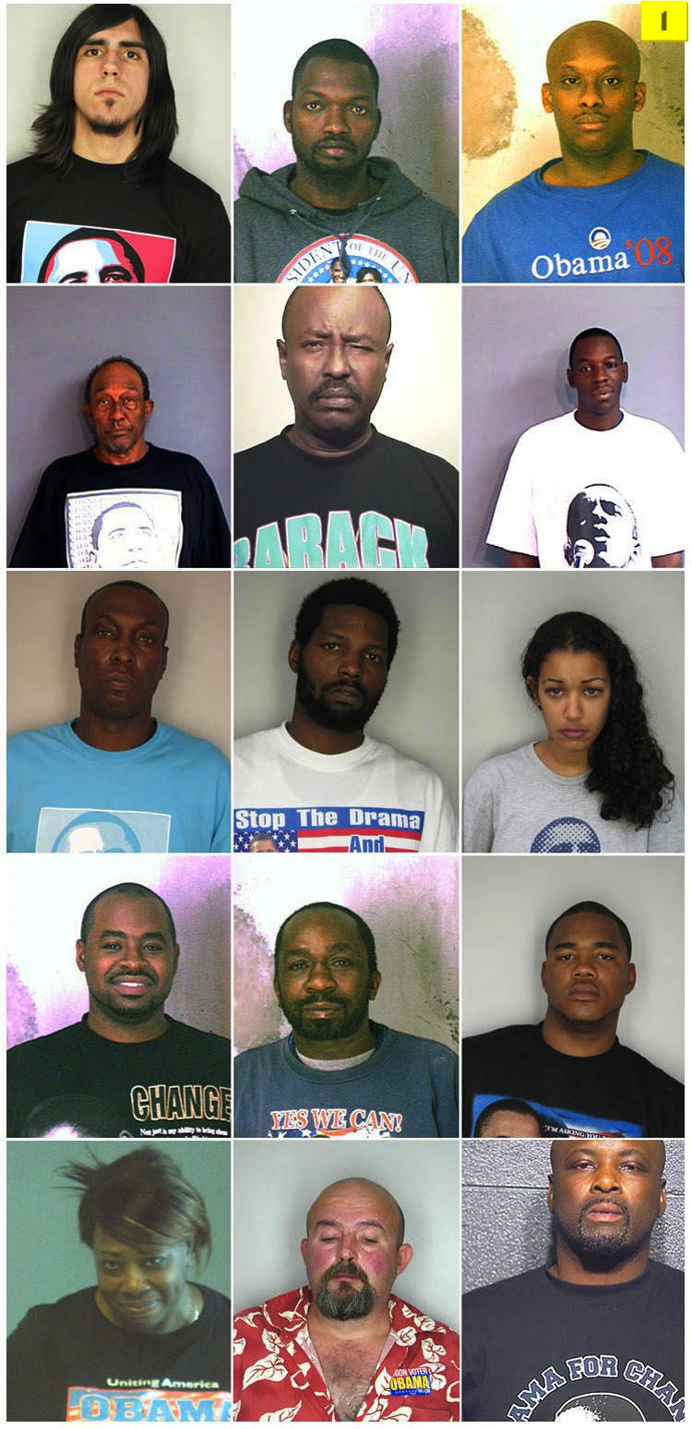

Just think about this for a second: Did you ever see anyone arrested wearing a Bush T-shirt, or for you older guys, an Eisenhower, Gerald Ford, Ronald Reagan, or even Nixon, or Bob Dole shirt.
Obama must be proud of his supporters!
Robert Stryk’s Response that was never printed by Sharon Stensaas:

For Immediate Release:

To Vice Mayor John Dunbar and the rest of the Town Council I would ask that you support me in rejecting bigotry and intimidation and ask for the immediate resignation of SGT Keith Behlmer and Officer Jon Thompson and ask the State Attorney General's office and the United States Department of Justice to launch an investigation into the Yountville Sheriff's department.

We as citizens must hold those who abuse their civic positions to a higher standard and make a statement that Yountville will not condone intolerance of people of differing racial, ethnic or religious faiths. And that all citizens have the right to be judged by their peers on a ballot, not in some sleazy back room.

To those enemies of change, that believe Yountville is their kingdom and we are nothing more then their servants, the clock is ticking.

To Vice Mayor John Dunbar personally, you owe not only myself but the citizens who you represent an apology. Somewhere along the way you forgot you are here as a servant of the people. Yountville deserves much better from its appointed Vice Mayor.

Nobody deserves to be Mayor, it must be earned. And come November win or lose I will continue to fight for the people of Yountville. Service does not begin or end at the ballot box, it is a calling that you are born with.

To all my friends, supporters and to the 3500 voters of Yountville, I am honored to call Yountville my home and I will work everyday to earn your trust and vote.

To Captain John Mcann of the United States Navy (Ret.) who lives at the Yountville Veterans Home, thank you for reminding me that when you choose to serve, you can't quit when the going gets tough.

In the end, Yountville is facing serious problems and it needs serious leadership from someone who has a plan to stimulate the economy through lower taxes, increased revenue and cost cutting.

I am the only candidate who has the experience, tenacity, drive and passion to lead Yountville into the next decade.

My name is Robert Stryk and I running for Mayor

￼

